**A.V.P COLLEGE OF ARTS AND SCIENCE**

**TEAM MEMBERS:** Kowshika,Nandhini,Shanmuga Priya,Aarthi

## Team Leader Name. **Kowshika.M**

**Email: kowshikaveera2006@gmail.com**

**Team Member1**: Nandhini.P

**Email: nandhiniparamasivamparamasivam@gmail.com**

**Team member2:** Shanmugapriya.K

**Email: shanmugapriyabanu0315@gmail.com**

**Team Member3:** Aarthi

**Email:** arthianusuya2006@gmail.com

# Creating Developer Account

Creating a developer org in salesforce.

1. Go to<https://developer.salesforce.com/signup>2. On the sign up form, enter the following details:

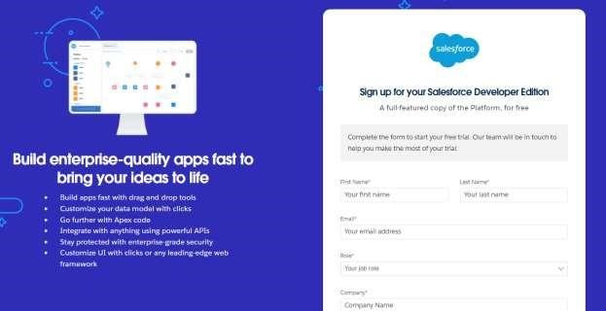

1. name & Last name
2. Email
3. Role: Developer
4. Company: College Name
5. Country: India
6. Postal Code: pin code
7. Username: should be a combination of your name and company This need not be an actual email id, you can give anything in the format

: username@organization.com Click on sign me up after filling these.

# Create Jewel Customer Object

The purpose of creating a Jewel Customer custom object is to store and manage information about Customer.

To create an object:

1. From the setup page >> Click on Object Manager >> Click on Create >> Click on Custom Object.

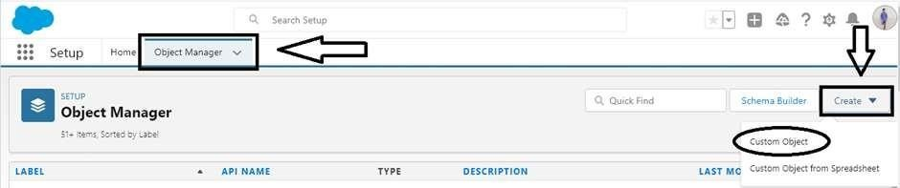

* 1. Enter the label name: Jewel Customer
  2. Plural label name: Jewel Customers

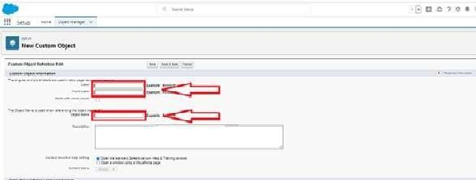

* 1. Enter Record Name Label and Format
     + Record Name >> Customer name
     + Data Type >> Text

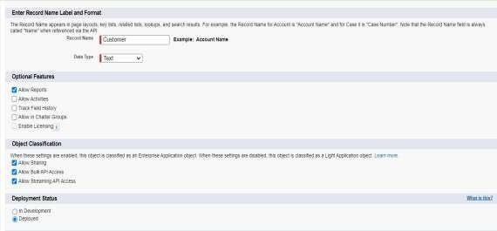

1. Click on Allow reports.
2. Allow search and click Save.

# Create Item Object

The purpose of creating a Item object is to manage the inventory of gold and silver items.

To create an object:

1. From the setup page >> Click on Object Manager >> Click on Create >> Click on Custom Object.
   1. Enter the label name >> Item
   2. Plural label name >> Items
   3. Enter Record Name Label and Format • Record Name >> Item Id
      * Data Type >> Auto Number
      * Display Format >> Item- {00}
      * Starting Number >> 1
2. Click on Allow reports.
3. Allow search >> Save.

Note: Create 3 more objects with label names as Customer Order, Price, Billing

**(**Use “Auto Number” as a data type for Customer Order, Price, Billing).

# Creating a Custom Tab

To create a Tab:(Customer)

1. Go to setup page >> type Tabs in Quick Find bar >> click on tabs >> New (under custom object tab)
2. Select Object (Jewel Customer) >> Select any tab style >> Next (Add to profiles page) keep it as default >> Next (Add to Custom App) keep it as

# To create a Tab:(Item)

1. Go to setup page >> type Tabs in Quick Find bar >> click on tabs >> New (under custom object tab)
2. Select Object (Item) >> Select the tab style >> Next (Add to profiles page) keep it as default >> Next (Add to Custom App) keep it as default >> Save. Note: Now create tabs for Customer Order, Price, Billing objects.

## Create a Lightning App

To create a lightning app page:

1. Go to setup page >> search “app manager” in quick find >> select “app manager” >>

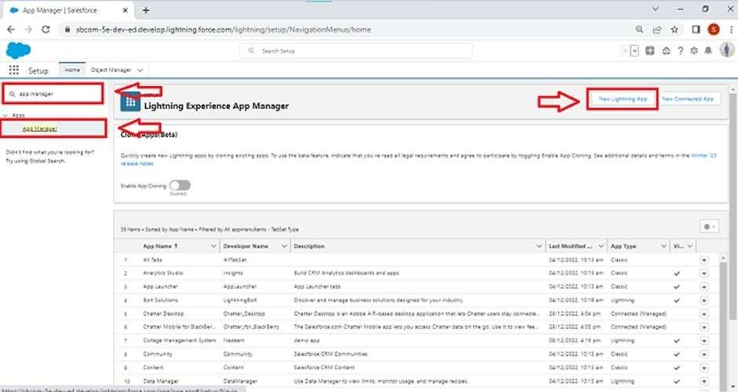

1. Fill the app name in app details and branding as follow App Name Jewelery: Inventory System.

Developer Name: This will auto populated

Description: Elevate your look with elegance

Image: optional (if you want to give any image you can otherwise not mandatory) Primary colour hex value : keep this default.

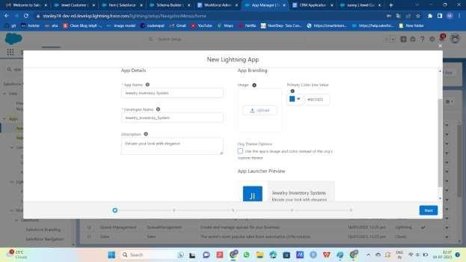

1. Then click Next >> (App option page) Set Navigation Style as Console Navigation >> Next.

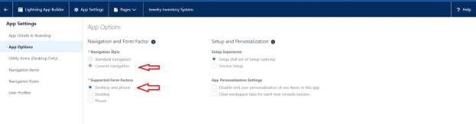

5.(Utility Items) keep it as default >> Next.

1. To Add Navigation Items:

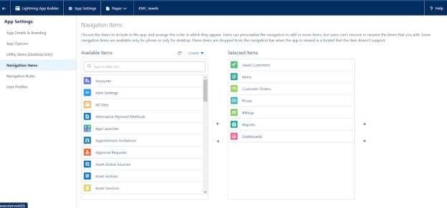

1. Search for the item in the (Jewel Customer, Item, Customer Order, Price, Billing, Reports, Dashboard) from the search bar and move it using the arrow button?

Next? Next.

1. To Add User Profiles:

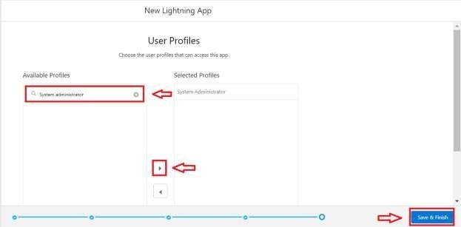

Search profiles (System administrator) in the search bar >> click on the arrow button >> save & finish.

# Creating Lookup Relationship

*a lookup relationship is a type of relationship in salesforce that connects two objects together based on a field known as the lookup field. it establishes a relationship between a child object and a parent object, allowing the child object to reference the parent object.*

To Create a relationship between Jewel Customer & Customer Order Objects.

1. Go to the setup page >> click on object manager >> type object name (Customer Order) in the quick find bar >> click on the object.
2. Click on fields & relationship >> click on New.
3. Select “Lookup relationship” as data type and click Next.
4. Select the related object “Jewel Customer”.
5. Give Field Label as “Customer” and click Next.
6. Next >> Next >> Save.

# Creating a Master-Detail Relationship

Master-detail relationship is a type of relationship between two objects where the master object controls certain behaviors and settings of the detail object. Here are a few use cases that demonstrate the use of master-detail relationships Creating Master-Detail Relationship between Item & Customer Order Object.

To Create a Master-Detail relationship:

1. Go to the setup page >> click on object manager >> type object name (Customer Order) in the quick find bar >> click on the object.
2. Click on fields & relationships >> click on New.
3. Select “Master-Detail relationship” as data type and click Next.
4. Select the related object “Item”.
5. Give Field Label as “Item” and click Next.
6. Next >> Next >> Save.

.

**.**

# Creating Text Field in Jewel Customer Object

To create fields in an object:

1. Go to setup >> click on Object Manager >> type object name(Jewel Customer ) in quick find bar >> click on the object.

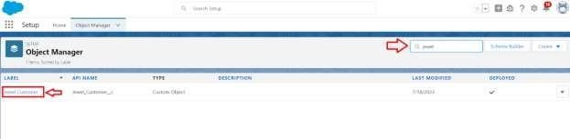

1. Now click on “Fields & Relationships” >> New

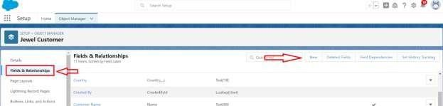

1. Select Data type as “Text”.

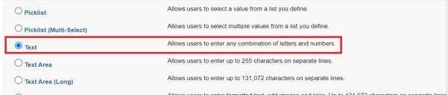

1. Click on Next

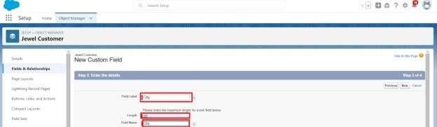

5.

Fill the above as following: o Field Label: City o Length: 20 o Field Name: gets auto generated o Click on Next >> Next >> Save and new.

## Creating the Phone field in object Jewel Customer

To create fields in an object:

1. Go to setup >> click on Object Manager >> type object name (Jewel Customer) in quick find bar >> click on the object.
2. Now click on “Fields & Relationships” >> New
3. Select Data type as “Phone” and click Next.
4. Given the Field Label as “Phone”.

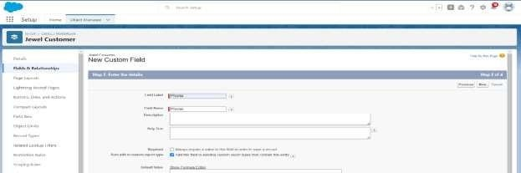

1. Field Name will be auto populated, and click on Next >> Next >> Save & new.

# Creating the Email field in object Jewel Customer

To create fields in an object:

1. Go to setup >> click on Object Manager >> type object name(Jewel Customer ) in quick find bar >> click on the object.
2. Now click on “Fields & Relationships” >> New
3. Select Data type as “Email” and click Next.
4. Given the Field Label as “ Email”.
5. Field Name will be auto populated, and click on Next >> Next >> Save.

## Creating the number field in Item object

To create fields in an object:

1. Go to setup >> click on Object Manager >> type object name(Item) in quick find bar? click on the object.
2. Now click on “Fields & Relationships” >> New
3. Select Data type as “Number” and click Next.
4. Given the Field Label as “Purity” and length as “2”.

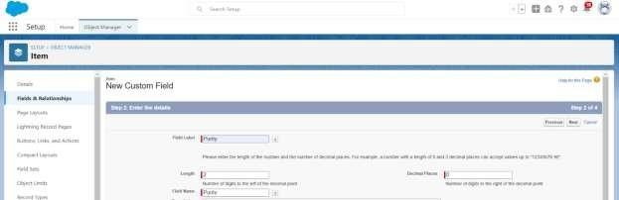

1. Field Name will be auto populated, and click on Next >> Next >> Save.

## Creating Picklist Field in Item Object

To create fields in an object:

1. Go to setup >> click on Object Manager >> type object name(Item) in quick find bar>> click on the object.
2. Now click on “Fields & Relationships” >> New.
3. Select Data type as “Picklist” and click Next.
4. Enter Field Label as “Item Type”.
5. In values select “Enter values (Gold, Silver), with each value separated by a new line" and enter values as shown below.

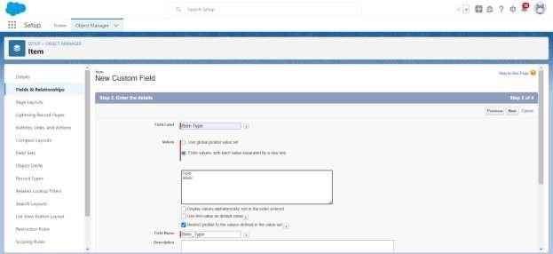

1. Click Next? Next? Next? Save.

# Creating Currency Field in Price Object

To create fields in an object:

1. Go to setup >> click on Object Manager >> type object name(Price) in quick find bar >> click on the object.
2. Now click on “Fields & Relationships” >> New.
3. Select Data type as “Currency” and click Next.

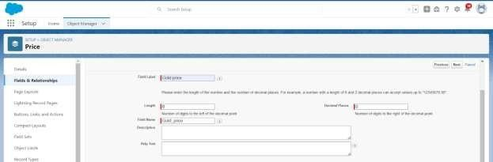

1. Enter Field Label as “Gold Price” and length as “ 8”and decimal 0.Field name will be auto generated.
2. Click Next >> Next >> Next >> Save

**Creating Formula Field (Cross Object) in Item Object**

# Creating Remaining Fields in Objects

Now create the remaining fields using the data types mentioned.

|  |  |  |
| --- | --- | --- |
| s.no | Object name | Fields |
| 1 | Jewel Customer | |  |  | | --- | --- | | Field Name | Data type | | State | Text (20) | | Street | Text (20) | | Country | Text (18) | | Zip/Postal code | Text (6) | |

|  |  |  |  |  |
| --- | --- | --- | --- | --- |
| 2 | Price | |  |  | | --- | --- | | Silver Price | Currency  (Length=8,Decimal=5) | |

|  |  |  |  |  |  |  |  |  |  |  |  |  |  |  |  |  |  |  |  |  |
| --- | --- | --- | --- | --- | --- | --- | --- | --- | --- | --- | --- | --- | --- | --- | --- | --- | --- | --- | --- | --- |
| 3 | Item | |  |  | | --- | --- | | Field  Label:Customer Name | Lookup Relationship with Jewel Customer Object | | Ornament | Text(20) | | Weight | Number (Length=8, Decimal=5) | | Stone Weight | Number (Length=5, Decimal=5) | | Percentage | Number (Length=2, Decimal=0) | | Stone/Other Price | Currency (Length=8, Decimal=2) | | Expected Days Of Return | Picklist     |  | | --- | | 1-3 Days  4-5 Days  6-7 Days  8-10 Days | | | Priority | Picklist     |  | | --- | | Low  Medium  High  Critical | | |

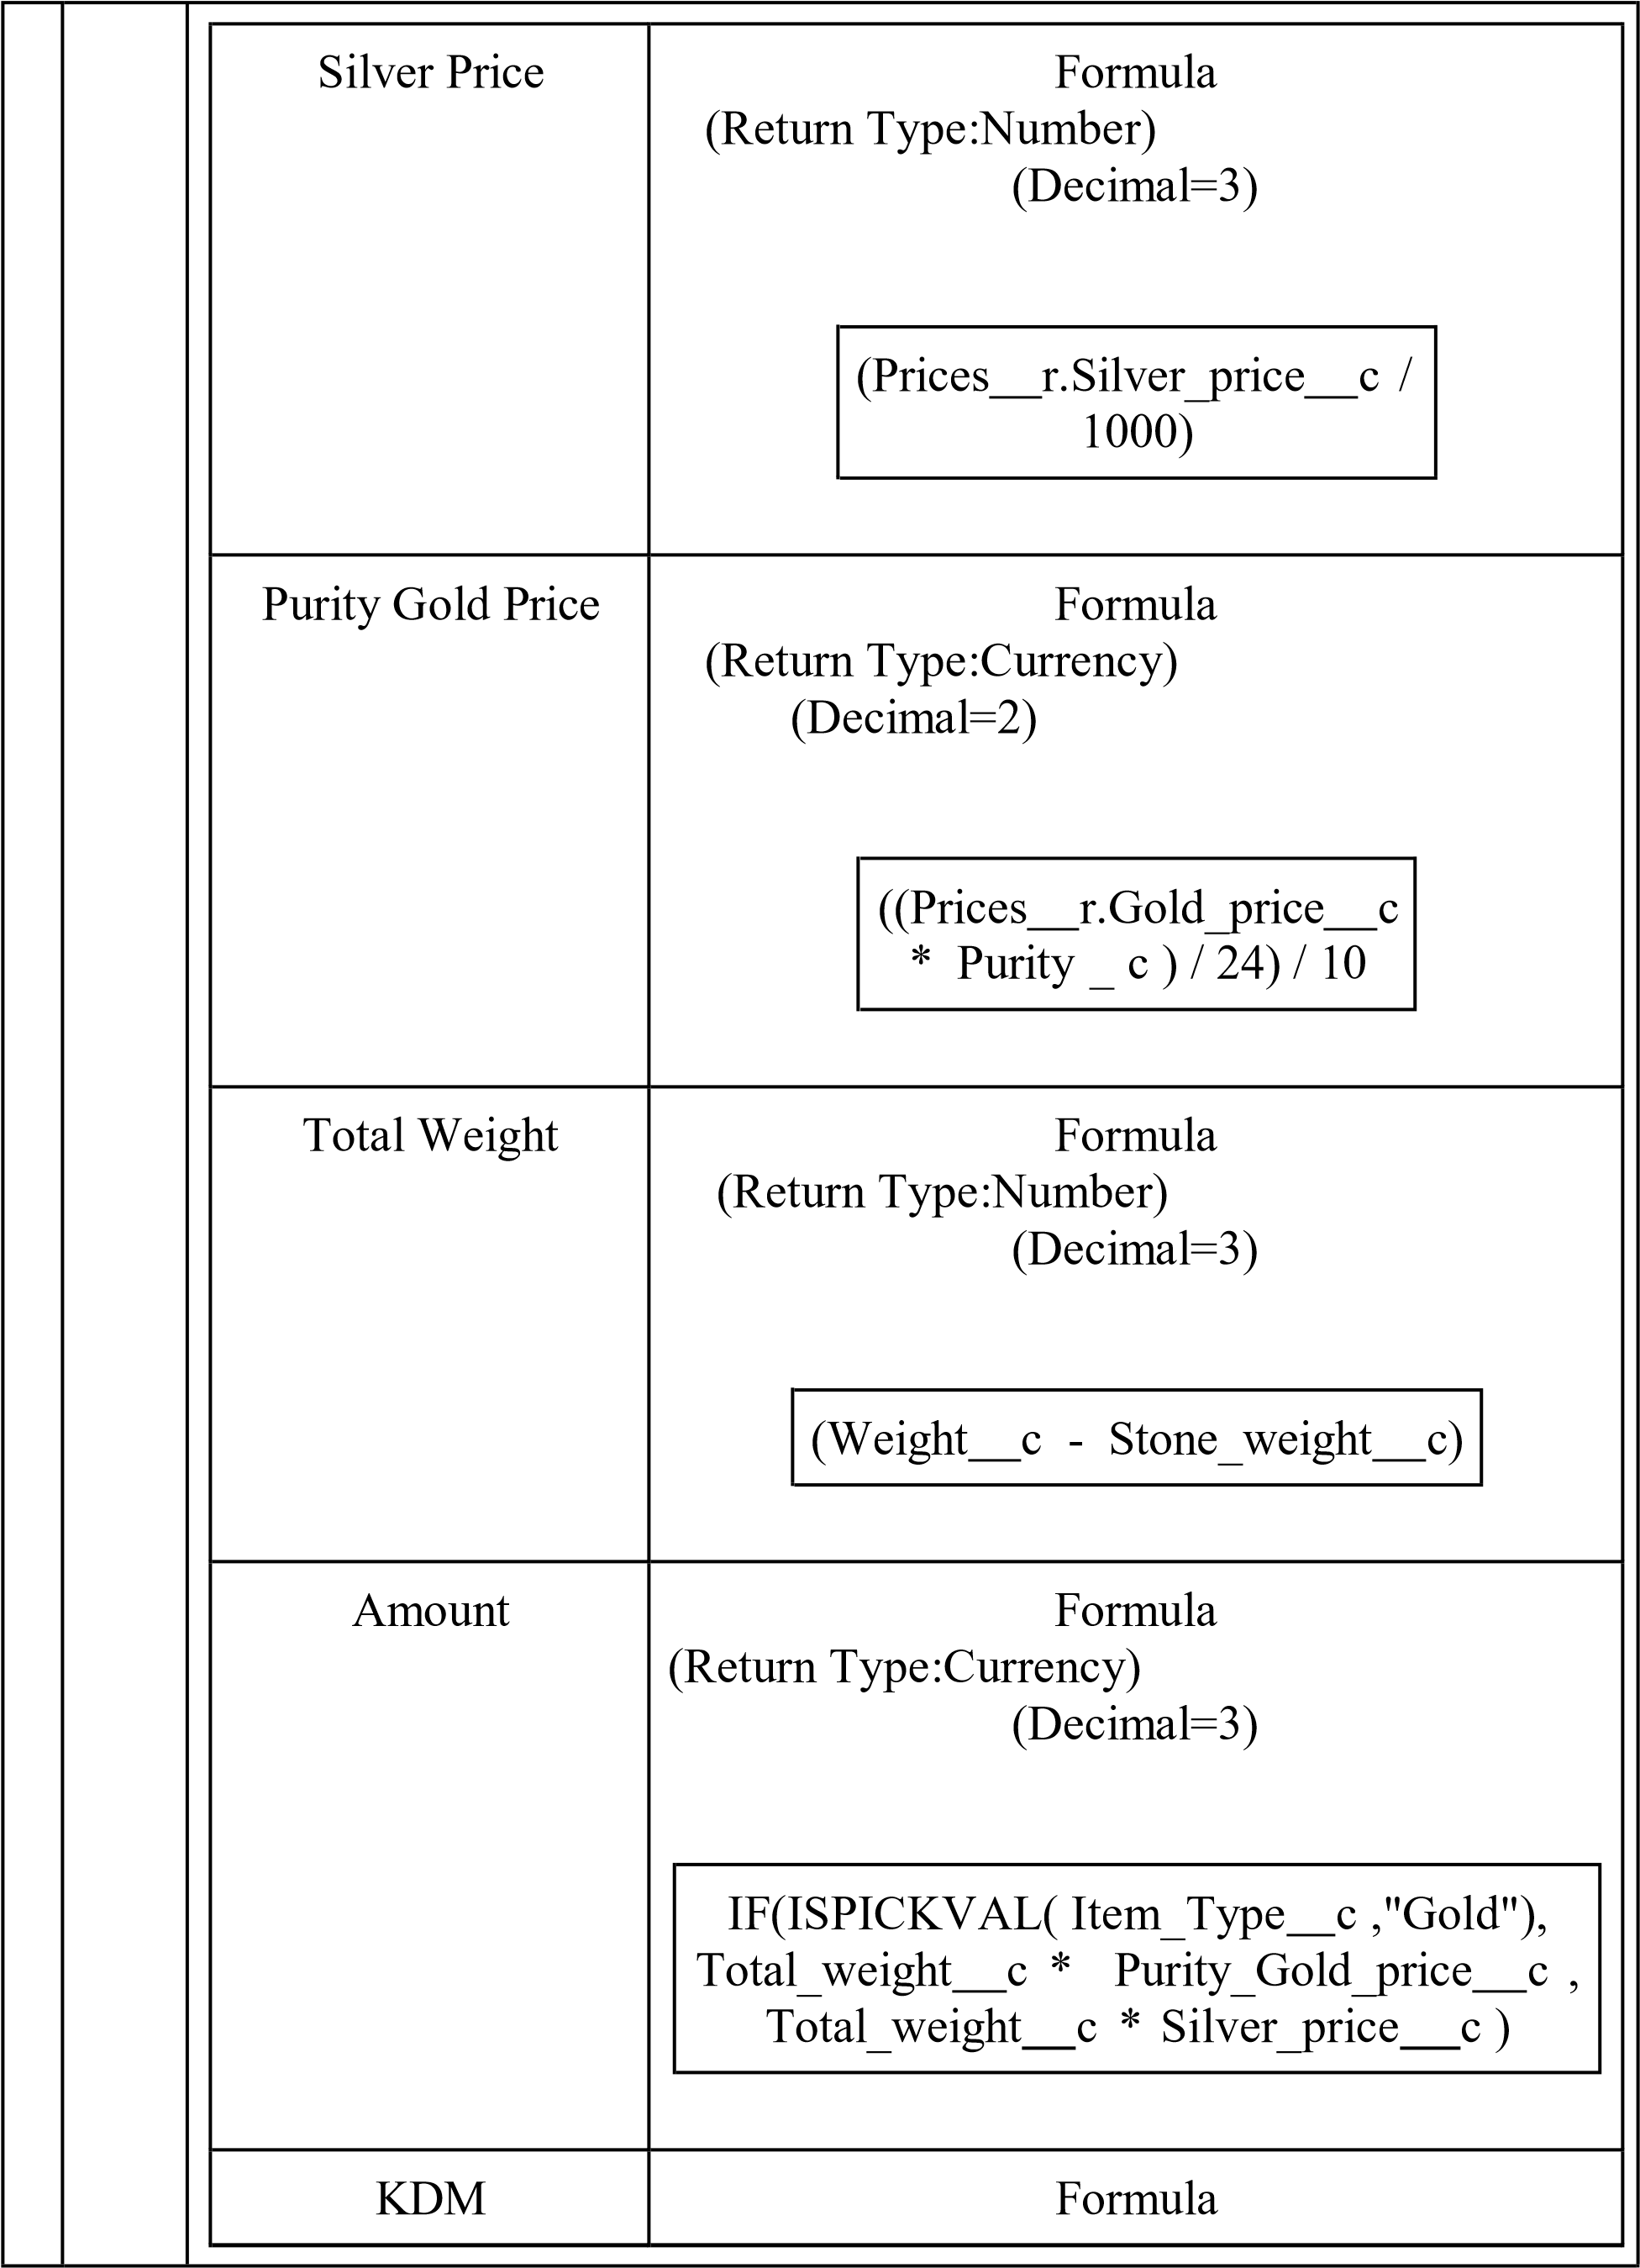

|  |  |  |  |  |  |  |  |  |  |  |
| --- | --- | --- | --- | --- | --- | --- | --- | --- | --- | --- |
|  |  | |  |  |  |  |  | | --- | --- | --- | --- | --- | |  | (Return Type:Currency)  (Decimal=0)     |  |  |  | | --- | --- | --- | | (Amount | c * Percentage  / 100 | c ) | | | Making Charges | Formula  (Return Type:Currency)  (Decimal=0)     |  | | --- | | IF(ISPICKVAL(  Item_Type c  ,"Gold"), Weight c * 300 , Weight c * 10 ) | | |

|  |  |  |  |  |  |
| --- | --- | --- | --- | --- | --- |
| 4 | Customer Order | |  |  |  | | --- | --- | --- | | Order Status | Picklist   |  | | --- | | Started  Not Started  On Hold  Completed  Not Completed | | |

# Creating the Field Dependencies

Use case:

Field Dependencies are used to create relationships between fields within an object. They allow you to control the visibility and availability of fields based on the values selected in other fields.

1. Go to setup >> click on Object Manager >> type object name (Item) in quick find bar >> click on the object.
2. Click on Fields & Relationships and click on the Priority field.
3. Search for Field Dependencies and click on New.

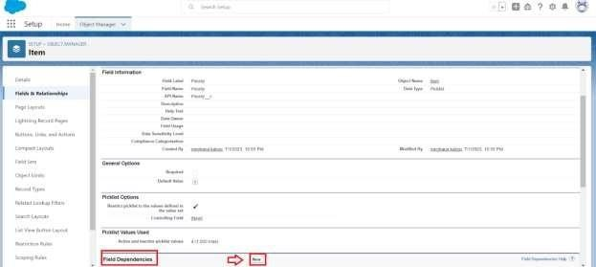

1. Select Controlling Field as “Priority” and Depending field as “Expected Days of Return” >> Continue.

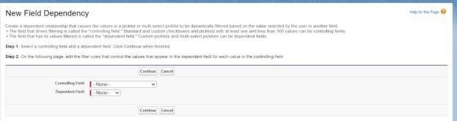

1. Select the “Expected Days of Return” values of related Priority values and Click on Include Values >> Save.

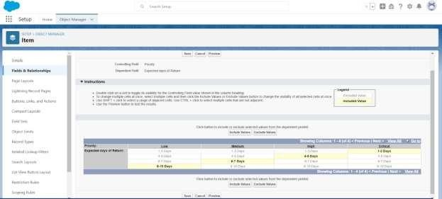

# Creating the validation rule

Creating the validation rule for Postal Code field in Jewel Customer object **Note**: check whether the fields mentioned in the formula field are created or not, if not go to activity 10 and create those fields mentioned in Jewel Customer object.

1. Go to setup >> click on Object Manager >> type object name (Jewel Customer) in quick find bar>> click on the object.
2. Click on the validation rule >> click New.

3.

1. Enter the Error Message as “Must contain 6 digits”, select the Error location as Field and select the field as “Zip/Postal code”, and click Save.

NOTE:

Create One more Validation rule for Jewel Customer object.

1. Enter Rule name as “Validation Rule for Jewel Customer Object “.
2. Insert the Error Condition Formula as : -

OR (ISBLANK (City c), ISBLANK (Country c), ISBLANK (Phone c

), ISBLANK (State c) ISBLANK (Street c))

1. Enter the Error Message as “Please fill Required fields”, select the Error location as Top of Page and click Save.

Create Validation rule for Item object.

1. Enter Rule name as “Validation Rule For Item”.
2. Insert the Error Condition Formula as : -

OR (ISBLANK (Amount c), ISBLANK (Customer _Name c)

ISBLANK (Gold _price c), ISBLANK (KDM c), ISBLANK (

Ornament c), ISBLANK (Percentage c), ISBLANK (Making_Charges c

), ISBLANK (Prices c), ISBLANK (Stone _weight c), ISBLANK (

Silver _price c), ISBLANK ( Stone_other_price c ),ISBLANK(

Stone_weight c ),ISBLANK( Weight c ))

1. Enter the Error Message as “Please fill Required fields”, select the Error location as Top of Page and click Save
2. Enter the Rule name as “Postal Code “.
3. Insert the Error Condition Formula as : -

AND(

OR(

LEN( Zip_Postal_code c ) <> 6, NOT(REGEX(Zip_Postal_code c,

"^[0-9]{6}$"))),

NOT(ISBLANK(Zip_Postal_code c))

)

)

# Gold Smith Profile

To create a new profile:

1. Go to setup >> type profiles in quick find box >>click on profiles? clone the desired profile (System Administrator) >> enter profile name (Gold Smith) >> Save.

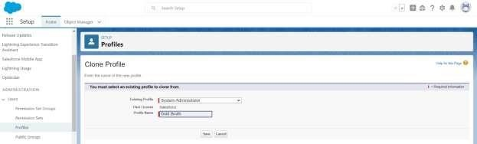

1. While still on the profile page, then click Edit.
2. Scroll down to Custom Object Permissions and Give access permissions for

Jewel Customer, Item, Customer Order, Prices, Billings

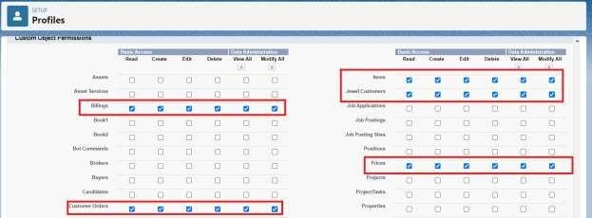

1. Scroll down and Click on Save.

.

# Worker Profile

1. Go to setup >> type profiles in quick find box >> click on profiles >> clone the desired profile (Salesforce Platform User) >> enter profile name () >> Save.
2. While still on the profile page, then click Edit.
3. Scroll down to Custom Object Permissions and Give access permissions for Items,Price and Customer Order objects.
4. Scroll down and Click on Save.

## Creating Gold Smith Role

1. From setup ,Go to quick find >> Search for Roles >> click on set up roles.

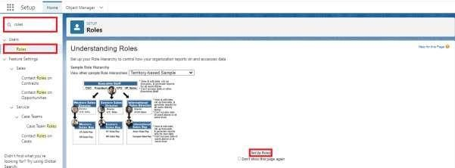

1. Click on Expand All and click on add role under whom this role works.

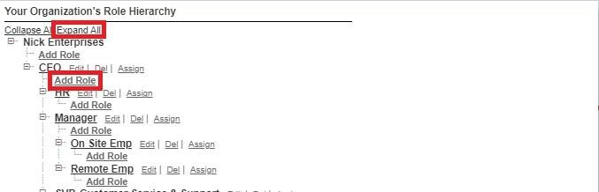

1. Give Label as “Gold Smith” and Role name gets auto populated. Check to whom this role (Gold Smith) reports. Then click on Save

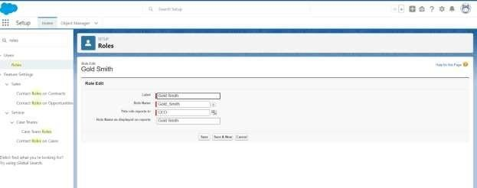

**Create one more role as Worker which reports to Gold Smith.** 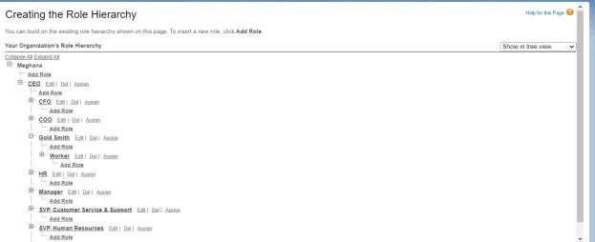

# Create User

1. Go to setup >> type users in quick find box >> select users >> click New user.
2. Fill in the fields
   1. First Name : Niklaus
   2. Last Name : Mikaelson
   3. Alias : Give a Alias Name
   4. Email id : Give your Personal Email id
   5. Username : Username should be in this form: text@text.text
   6. Nick Name : Give a Nickname
   7. Role : Gold Smith
   8. User licence : Salesforce
   9. Profiles : Gold Smith

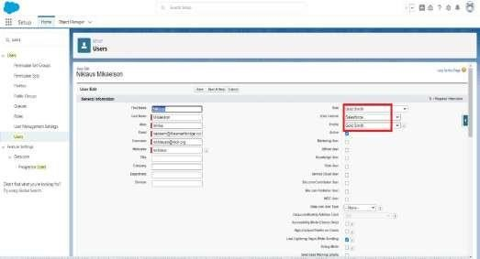

1. Save.

# Create User

1. Go to setup >> type users in quick find box >> select users >> click New user.
2. Fill in the fields
   * First Name : Kol
   * Last Name : Mikaelson
   * Alias : Give a Alias Name
   * Email id : Give your Personal Email id
   * Username : Username should be in this form: text@text.text
   * Nick Name : Give a Nickname
   * Role: Worker
   * User licence : Salesforce Platform
   * Profiles: Worker
3. Save.

Note:

Create two more users as mentioned in activity 2 using the same profile.

# Page layouts

Page Layout in Salesforce allows us to customise the design and organise detail and edit pages of records in Salesforce. Page layouts can be used to control the appearance of fields, related lists, and custom links on standard and custom objects' detail and edit pages.

Use Case:

Hurray!! you have completed the data model structure for your organisation but while looking at the detailed and edit pages it seems to be so clumsy, so decide to organise the page in a pleasant way for the sake of good and pleasant appearance and assemble all different kinds of information in different sections in order.

# To Create a Gold Page layout

1. Go to Setup >> Click on Object Manager >> Search for the object (Item) >> From drop down click on Edit.
2. Click on Page layout >> Click on New.

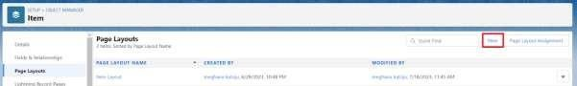

1. Give Page layout Name as “Page Layout for Gold” and click on Save and New.

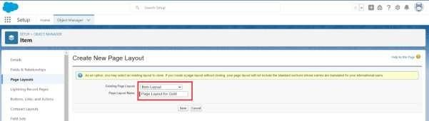

1. Arrange the field as shown in the Information Section ,remove fields which are related to Silver and click Ok.

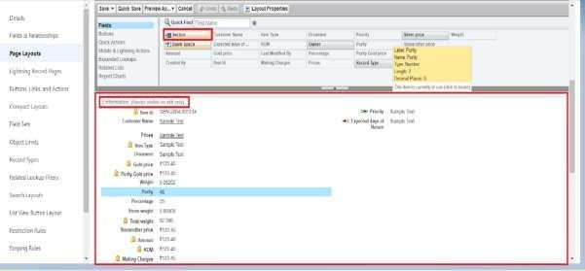

1. Click Save.
2. Make sure your page layout looks like the picture above

## To Create a Silver Page layout

1. Go to Setup >> Click on Object Manager >> Search for the object (Item) >> From drop down click on Edit.
2. Click on Page layout >> Click on New.
3. Give Page layout Name as “Page Layout for Silver” and click on Save.
4. Arrange the field as shown in the Information Section, remove fields which are related to Gold and click Ok.

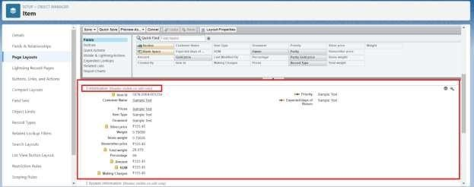

**To create a Record Type**

1. Go to setup >> click on Object Manager >> type object name(Item) in quick find bar? click on the object.
2. Click on the Record Types >> click New.

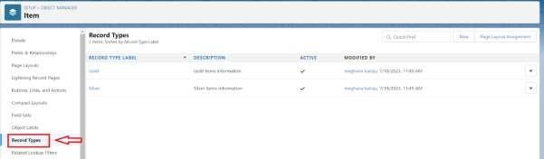

1. Select Existing Record as “Master”, Record type Label as “Gold”, Description as “Gold items information”.

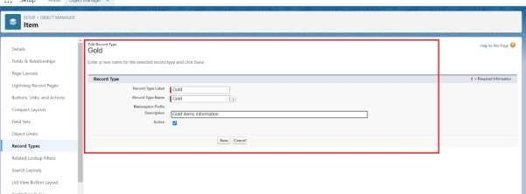

1. Uncheck for “Make Available”.

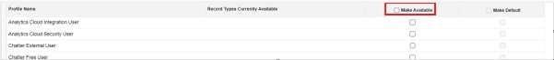

1. Scroll down and check for the Gold Smith, Worker JW & System Administrator profile and click on Next.

# Creating permission set

A permission set is a collection of settings and permissions that give users access to various tools and functions. Permission sets extend users' functional access without changing their profiles. Users can have only one profile but, depending on the Salesforce edition, they can have multiple permission sets.

1. Go to setup >> type “permission sets” in quick search >> select permission sets >> New.

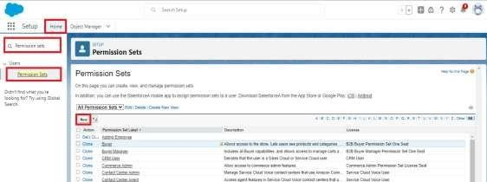

1. Enter the label name as “Per to Wo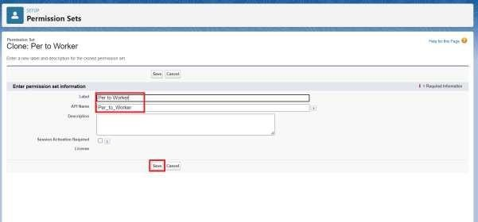rker”, API will be auto populated ? save.
2. Under Apps Select object settings.

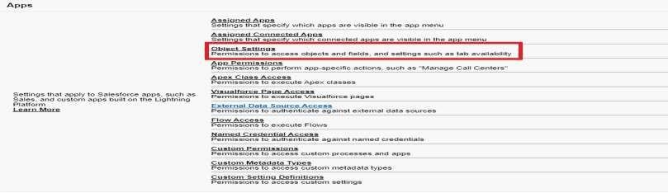

1. Click on Items object? click on Edit? under Item: Record Type Assignments, enable Gold, Silver? Object permission check for read, edit and create.

# Create a Trigger Handler class

**Trigger handler:**

A trigger handler is a design pattern that organises trigger logic into separate classes. This helps in keeping code organised, reusable, and easier to maintain. The trigger handler class contains methods that handle the specific logic for different trigger events, improving code structure and readability. This approach is particularly useful for complex triggers or projects with multiple triggers, as it promotes modular coding practices and reduces the chances of code duplication.

**CODE:**

public class UpdatePaidAmountTriggerHandler { public static void handleBeforeInsert(List<Billing c> newBillings) { for (Billing c billing : newBillings) {

billing.Paid_Amount c = billing.Paying_Amount c;

}

}

public static void handleBeforeUpdate(Map<Id, Billing c> oldBillingsMap,

List<Billing c> updatedBillings) { for (Billing c billing : updatedBillings) {

Billing c oldBilling = oldBillingsMap.get(billing.Id); Decimal oldPaidAmount = oldBilling.Paid_Amount c;

billing.Paid_Amount c = oldPaidAmount + billing.Paying_Amount c;

}

# Create the trigger

**CODE:**

trigger UpdatePaidAmountTrigger on Billing c (before insert, before update) { if (Trigger.isInsert) {

UpdatePaidAmountTriggerHandler.handleBeforeInsert(Trigger.new);

} else if (Trigger.isUpdate) {

UpdatePaidAmountTriggerHandler.handleBeforeUpdate(Trigger.oldMap,

Trigger.new); }

}

# Create a Record (Jewel Customer)

1. Click on App Launcher on the left side of the screen.
2. Search Jewelry Inventory System & click on it.

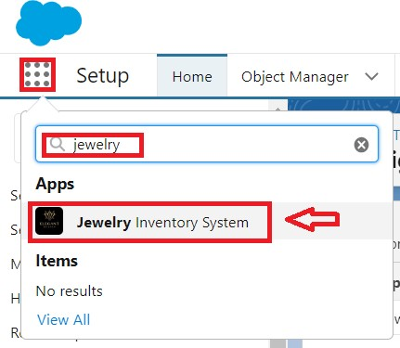

1. Click on Drop Down and Click on the Jewel Customer tab.
2. Click New.

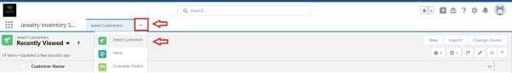

1. Fill the Details and click on Save.

# View a Record (Jewel Customer)

1. Click on App Launcher on the left side of the screen.
2. Search Jewelry Inventory System & click on it.
3. Click on the Jewel Customer Tab.
4. Click on any record name. you can see the details of the Jewel Customer.

## Delete a Record (Jewel Customer)

1. Click on App Launcher on the left side of the screen.
2. Search Jewelry Inventory System & click on it.
3. Click on the Jewel Customer Tab.
4. Click on Arrow at right hand side on that Particular record.
5. Click delete.

**Note:** Create at least 10 records for each of the objects: Jewel Customer, Price, Item, Customer Order and Billing.

# Create Report

1. Go to the app >> click on the reports tab
2. Click New Report.

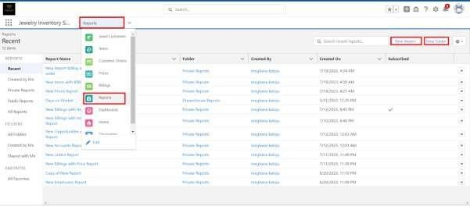

1. Select report type from category or from report type panel or from search panel? click on start report.

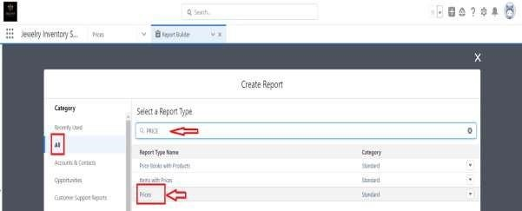

1. Customise your report

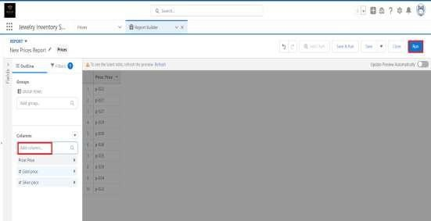

• Add fields from the left pane as shown below.

1. Save or run it.

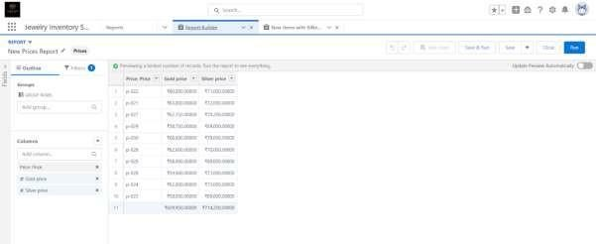

Note: Reports may get varied from the above pictures as the data might be different.

# Reports

1. Create a report with report type: “Item with Billings”.
2. Create a report with report type: “Billings with item and Customer order” **Create Dashboard**
3. Go to the app >> click on the Dashboards tabs.

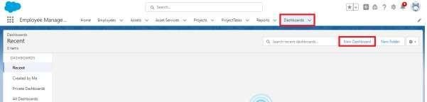

1. Give a Name and click on Create.

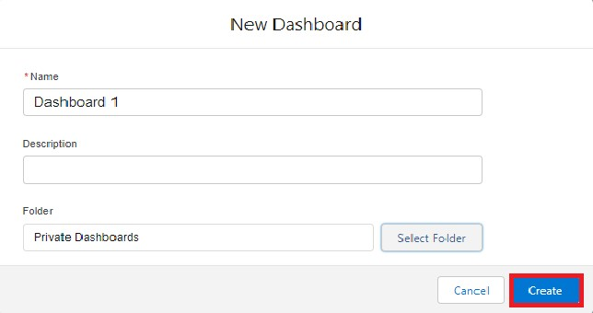

1. Select add component.



1. Select a Report and click on select.

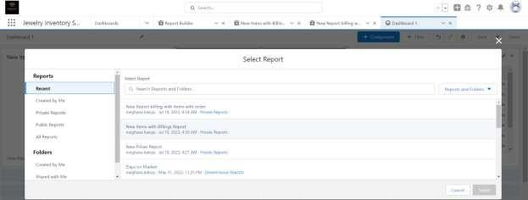

1. Click Add then click on Save and then click on Done.

Activity 2: Create another Dashboard as we discussed in activity 1.

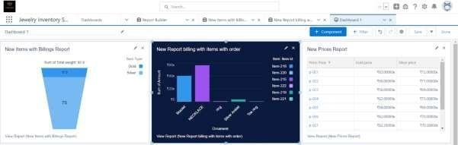

# Create a Flow

1. Go to setup >> type Flow in quick find box >> Click on the Flow and Select the New Flow.

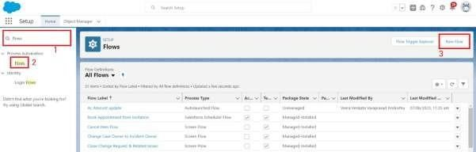

1. Select the Record-triggered flow and Click on Create.

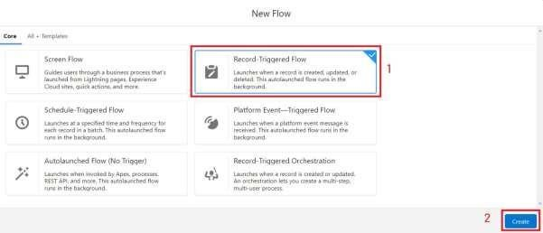

1. Select the Object as a “Billing” in the Drop down list.
2. Select the Trigger Flow when: “A record is Created or Updated”.
3. Select the Optimise the flow for: “Actions and Related Records” and Click on Done.

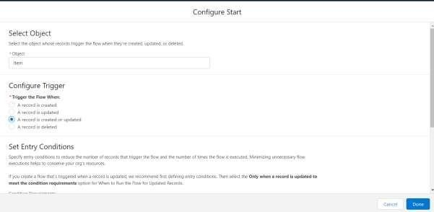

1. Now change the mode form Auto-layout to free-form.
2. Now select the manger option in the toolbox, click New resource.
3. Select the resource type as text template.

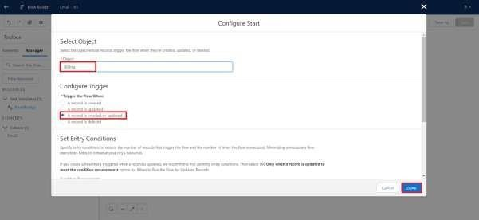

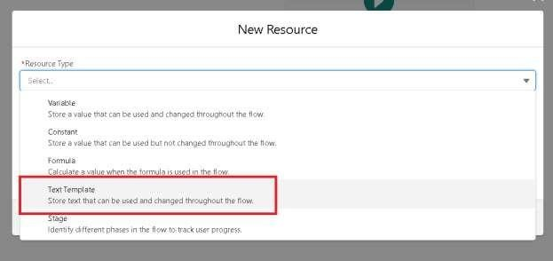

1. Enter the API name as “ Email body”.

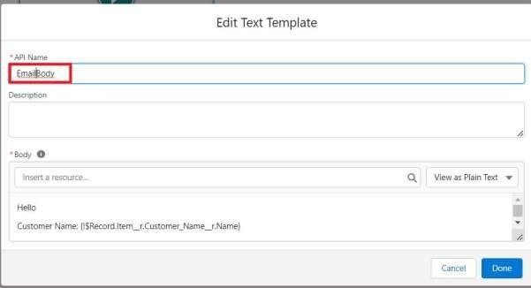

1. Change the view as Rich Text? View to Plain Text.
2. In the body field paste the syntax that is given below.

Hello

Customer Name: {!$Record.Item r.Customer_Name r.Name}

Here are the details for the item you purchased with Jewellery Inventory

System

Item Type: {!$Record.Item r.Item_Type c}

Ornament: {!$Record.Ornament c}

Weight: {!$Record.Weight c}grams

Amount: {!$Record.Amount c}

1. Click done.
2. Now click on elements, and drag the action element into the preview pane.
3. Their action bar will be opened in that search for “ send email ” and click on it.
4. Give the label name as “notice”
5. API name will be auto populated.
6. Enable the body in set input values for the selected action.
7. Select the text template that was created.

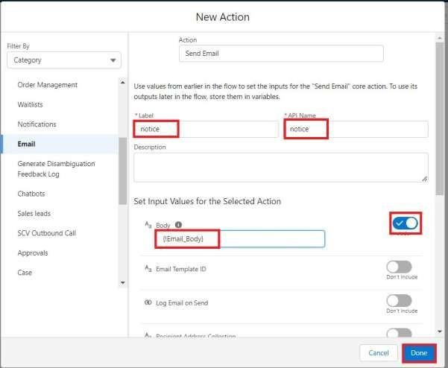

1. Include Recipient Address list, select the email form the record. ({!$Record.Item_r.Customer_Namer.Email_c})
2. Include the subject as “Welcome to Jewelry Inventory System ”.
3. Click done.

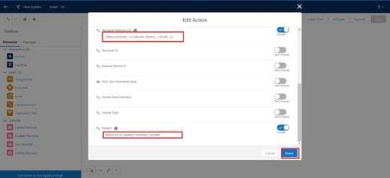

1. Now drag the path from the start to the action element.
2. Click on save. Given the Flow label, Flow Api name will be auto populated.
3. And click save, and click on activate.

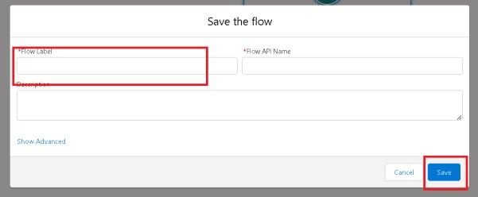

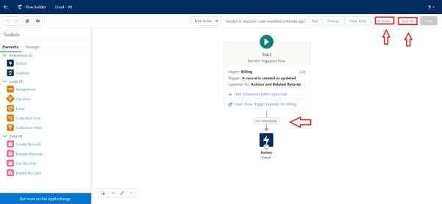

**ADVANTAGES & DISADVANTAGES**

* **Centralized Customer Data** – Easy integration of customer purchase history, preferences, and trends into one platform.

* **Customization Flexibility** – CRM allows developers to tailor features like loyalty programs, offers, and personalized catalogs for jewel businesses.

* **Scalability** – Can scale the system for multiple branches or online stores with minimal additional coding effort.
* **Integration Capabilities** – Developers can integrate with POS, ERP, or e-commerce systems to streamline jewel sales and inventory management.

* **Automation Support** – Automates routine tasks like follow-ups, reminders for festivals/weddings, and client relationship tracking.

* **Data Analytics & Reporting** – Enables developers to build dashboards for sales insights, demand forecasting, and customer segmentation.

* **High Development Complexity** – Jewelry CRMs require features like gold rate updates, valuation tools, and custom catalogs, which increase coding effort.

* **Costly Implementation** – Developing advanced features (AI recommendations, cloud storage, etc.) demands high resources.

* **Integration Challenges** – Difficulties in connecting with existing jewel shop software (inventory, accounting, or POS).

* **Data Security Risks** – Sensitive customer and financial data need strong protection; failure may lead to data breaches.

* **Maintenance Overhead** – Developers must constantly update tax rules, gold price APIs, and new business requirements.

## CONCLUSION

From a developer’s perspective, building a **CRM Application for Jewel Management** provides immense value by streamlining customer relations, automating sales processes, and integrating inventory with client data. It empowers jewel businesses with personalized services, secure data handling, and data-driven decision-making. However, the development process also comes with challenges such as high customization demands, integration complexities, security concerns, and ongoing maintenance.

Overall, a well-designed CRM for jewel management can serve as a **powerful technological bridge** between jewelers and customers, enhancing business efficiency and customer satisfaction. For developers, it offers both **opportunities to innovate** in a niche industry and **responsibilities to ensure reliability, security, and scalability** of the solution.